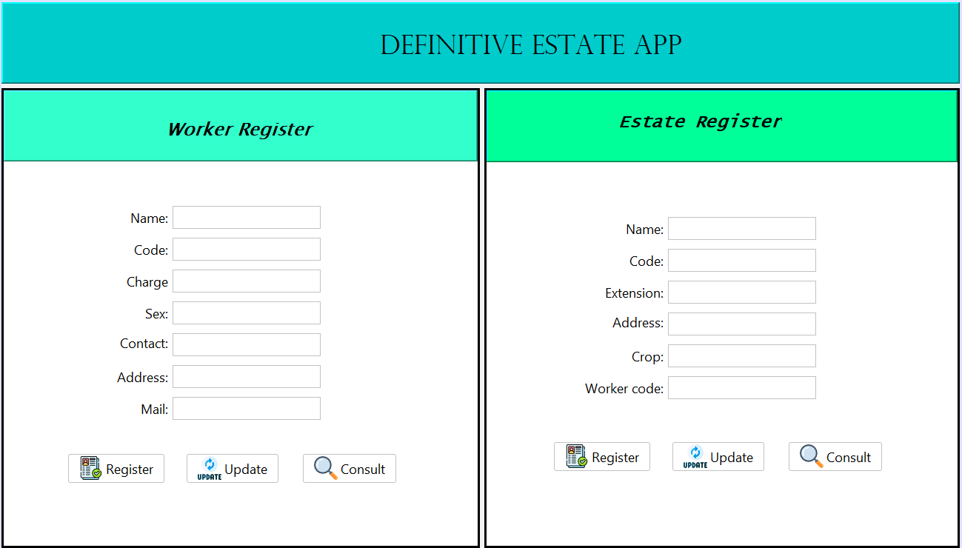

Worker Register

1. Name = save the variable name.

2. Code = save the variable code, then we use this variable for the consult and update button.

3. Charge = save the variable charge.

4. Sex = save the variable sex.

5. Contact = save the variable contact.

6. Address = save the variable address.

7. Mail = save the variable mail.

8. Register button = Work for save all the request, if some space was empty, the program say: fill all the information.

9. Update button = Use for change all the variable except the code.

10. Consult button = Use to know some consult from the workers list.

Estate Register

1. Name = save the variable name.

2. Code = save the variable code for the allotment.

3. Extension = save the extension.

4. Address = save the address.

5. Crop = save the variable crop.

6. Worker code = save the Worker code for the allotment.

7. Register button = Work for save all the information from the allotments.

8. Consult button = Use to consult some allotments from the workers.

9. Update button = Use to update some request from the allotment.